Canine Dentition
Adult dogs have 42 permanent teeth
(20 upper and 22 lower teeth)
Puppies have 28 baby (deciduous) teeth
(14 upper and 14 lower teeth)
Puppies should have 28 temporary teeth that erupt at about 3-4 weeks of age. They will eventually have 42 permanent adult teeth that begin to emerge at about 3-4 months of age. As puppies, there are 14 upper and 14 lower puppy teeth. Puppies do not have any of the molars or premolar 1.

Tooth Emergence Schedule
Deciduous Permanent
Incisors 4-6 weeks 3-5 months
Canine 5-6 weeks 4-6 months
Premolars 6 weeks 4-5 months
Molars 5-7 months

Teeth Types and Function
The chewing forces in the dog have been estimated to be 300 to 800 psi (pounds per square inch) as passive bite force, and with a sudden localized bite force when snapping the jaws shut of as much as 30,000 to 80,000 psi.
There are 4 types of teeth with different functions:
- Incisors - used for cutting and nibbling food, scooping, picking up objects and grooming; these are the front teeth situated directly in between the canines; in adults and puppies there are 6 upper and 6 lower all in a row; the center two incisors are usually somewhat smaller and the others get larger as they move out and away from the center
- Canines - used for holding and tearing prey/food, slashing and tearing when fighting and as a cradle for the tongue; these are the large fangs; the lower canines lock in position in front of the upper canines; the canines are situated directly between the incisors and premolars; in adults and puppies there are two upper and two lower canines, one upper and lower on each side of the jaw
- Premolars - used for cutting, holding, shearing, carrying and breaking food into small pieces; these teeth are situated between the canines and molars; puppies do not have P1 teeth, only P2, P3, P4; adults have 8 premolars on the top and 8 on the bottom, 4 on each side of the upper and lower jaws
- Molars - used for grinding food into small pieces with flat occlusal tables; the molars are situated behind the premolars and are the last teeth in the back of the jaw; puppies do not have molars; adults have 4 molars on the top, two on each side of the upper jaw and 6 molars on the bottom, 3 on each side of the lower jaw
Adult Canine Dentition Chart
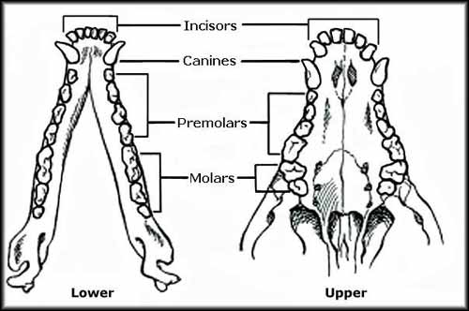

Important Puppy Teeth Information
Puppies should lose a puppy tooth before the corresponding adult tooth emerges, but many times with Maltese, and other toy breeds, you will see both the puppy tooth and the adult tooth side by side. This is especially common with the canines. If a puppy tooth is still in place when an adult tooth begins to show, and it shows no signs of loosening, you need to consult with your veterinarian to decide if the puppy tooth needs to be pulled so the dog's bite will not be affected.
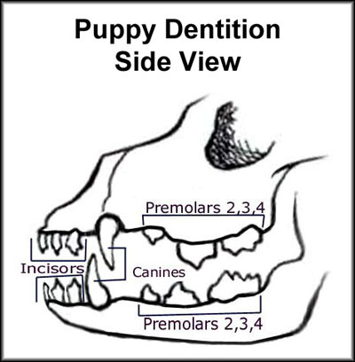
It is very important to keep a close eye on your puppy's teeth as they emerge. Any abnormalities need to be dealt with promptly.
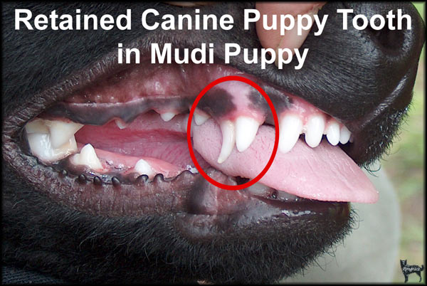

Correct and Incorrect Bites

The correct bite in the Maltese is a scissors bite or even bite.

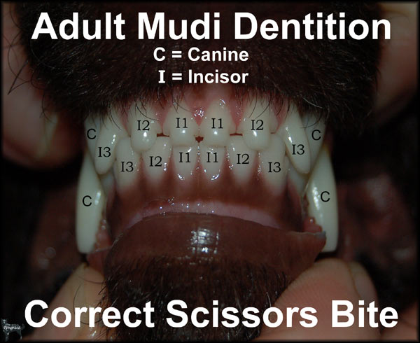
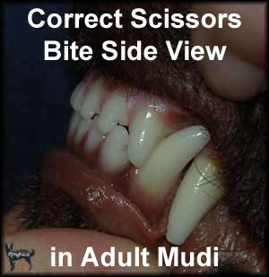

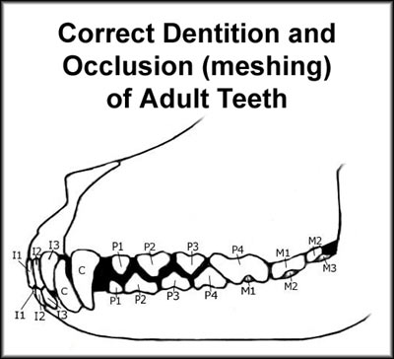

Incorrect Bites
Overbite (overshot), underbite (undershot) and wry mouth (wry bite) are faults.
The even or scizzor bite is the correct bite in Maltese standard.

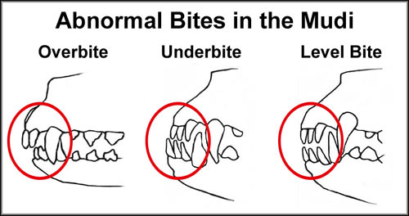

Teeth and Bite Genetics

Heredity of teeth and bite is mostly unknown and presents a confusing pattern. That is, it is mostly unknown if it is dominant, recessive or polygenic for each abnormality. However these teeth and bite faults can be seen with a simple visual inspection by the age of 1, which means that affected dogs can easily be kept from breeding. The most commonly seen issues in dogs are missing teeth , oligodontia (absence of most if not all teeth, not seen in the Maltese), overbite/overshot bite , retained deciduous teeth (baby teeth do not fall out by themselves, extra teeth (rarely occurs in the Maltese), underbite/undershot bite and wry mouth.

Studies of dentition done by Willis with German Shepherds, were not indicative of any simple mode of inheritance. Willis also reported that the difficulty of identifying the heredity of missing teeth is compounded by the fact that apparently missing teeth are sometimes present below the gum rather than totally absent. It is his opinion that faulting individuals for such a trait with such poorly understood inheritance may be dangerous in that the dogs otherwise outstanding qualities may be discarded from a breeding program.

Abnormal bites vary in levels of severity. Some breeds and some lines within breeds appear to have a higher incidence of bite faults than others. It is seen that some lines or individuals do produce more incorrect bites than breed averages, leading to a general familial inheritance pattern. Some researchers have suggested that the shortening of the lower jaw and muzzle might be responsible for incorrect bites and missing teeth.

Upper and lower jaw structure appear to be independently inherited traits and even the size of the incisors may play a role in occlusion. Abnormal size and overly vertical incisors can create incorrect bite. The growth of the lower jaw may not parallel the rest of the head.

Puppy Bite Information
In general, a puppy's bottom jaw will continue to grow until they are approximately 9 months old, which means the bite is in transition until 9-11 months of age. It should be noted that the top jaw is also in transition and growing during this period. The bite can go either way, from scissors to underbite or from scissors to overbite, or from scissors to level bite. It is a general observation in some breeds that a puppy which starts off with an overbite, even if it corrects later on, can have a higher incidence of producing more puppies with overbites. Puppies with underbites almost never correct themselves.

Broken Teeth and Gum Disease

A broken tooth sometimes occurs, especially among active or outdoor dogs. Aggressive chewing on hard objects, such as rocks, fences, bones or other solid items, is a common cause, as is contact with foreign objects such as collars and other dogs teeth or skulls during a fight or collision. It has also been noticed that dogs which mouth tennis balls very often, also wear their teeth down very quickly. Bites should be checked often and if you notice the teeth are shifting or wearing down, you should remove any objects the dog is chewing on. Canines can lose a tooth by pulling on fences, crate doors and other firmly attached objects. It is also possible for dogs to lose teeth from doing bite work and teeth can be pulled out of alignment from tug-of-war games. It is important to check your dogs teeth often and correct any issues which may be causing a problem.

Studies show that by age three, 80 percent of dogs exhibit signs of gum disease. Symptoms include yellow and brown build up of tartar along the gumline, red inflamed gums and persistent bad breath. Plaque on dog's teeth is a concern because it can lead to heart disease. It is highly recommend that you keep your dog's teeth clean by offering sturdy raw bones on a regular basis. Cooked bones are too hard on the enamel of the teeth and can splinter. You can also buy dog toothpaste and a dog toothbrush and brush your dogs teeth on a regular basis.

